**INTRODUCTION TO DIGITAL SYSTEMS, SAMPLING AND ENCODING**

Electronic devices becoming digital.

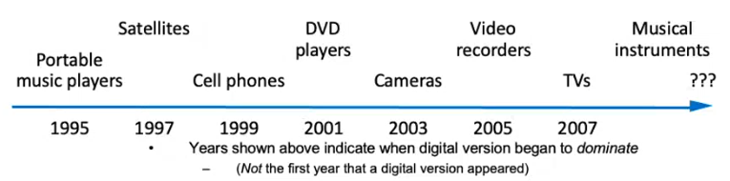

What Does “Digital” Mean?

Analog signal:

Digital signal:

* Finite possible values
  + Ex: button pressed on a keypad
* Infinite possible values
  + Ex: voltage on a wire created by

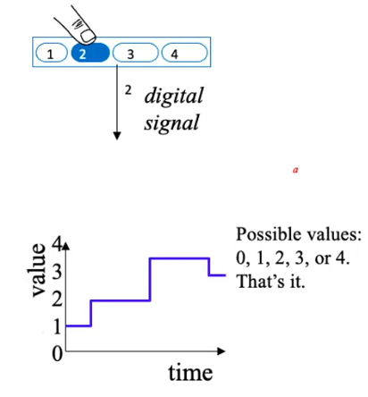microphone

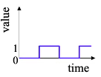Binary digital signal 🡪 only 2 possible values ( 0 and 1 ). We will only consider binary digital signals.

1 binary digit is a bit.

Binary is popular bc transistors (the basic digital electric component) operate using 2 voltages and storing/transmitting one of 2 values is easier than 3 or more (e.g., loud beep or quiet beep, reflection or no reflection).

Digitalization benefit:

* Analog signal (e.g., audio, video) may lose quality
  + Voltage levels not saved/copied/transmitted perfectly
* Digitized version enables near-perfect save/cpy/tran.
  + “Sample” voltage at particular rate, save sample using bit encoding
  + Voltage levels still not kept perfectly
  + We can distinguish 0s from 1s

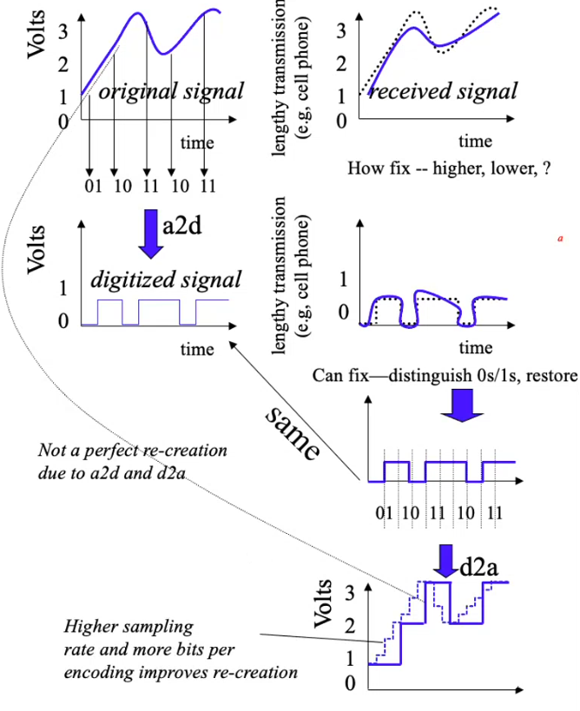

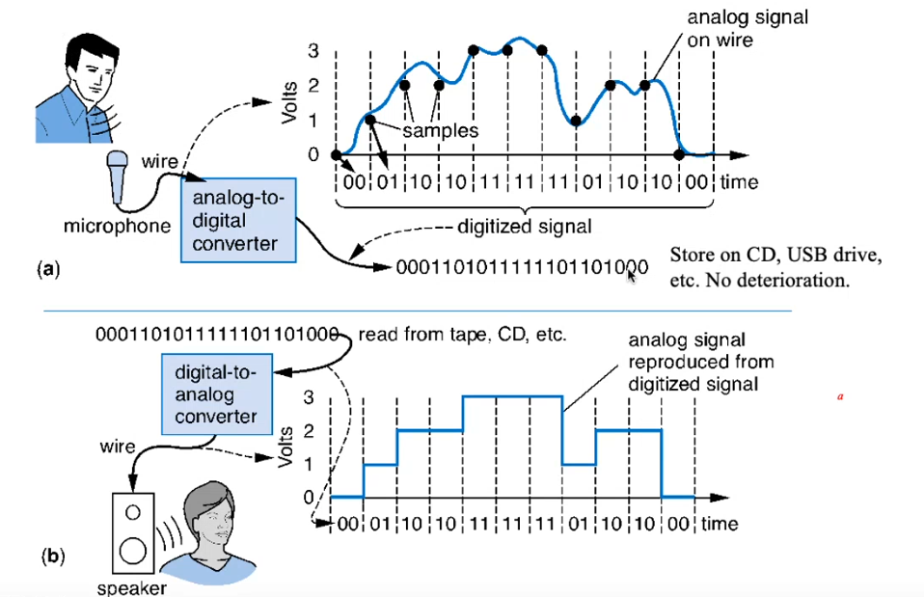

Neden tekrar analog sinyale dönüştürüyoruz?

Garip sesler çıkar. Kulaklarımız analog şekilde duyuyor.

Digitized Audio: Compression Benefit

Digitized audio can be compressed.

* e.g., MP3
* A CD can hold about 20 songs uncompressed, but about 200 compressed

Compression also done on digitized pictures (jpeg), movies (mpeg), and more.

Digitization has many other benefits too.

Example compression scheme:

* 00 means 0000000000
* 01 means 1111111111
* 1X means X

0000000000 0000000000 0000001111 1111111111 🡪 00 00 10000001111 01

How Do We Encode Data as Binary for Our Digital System?

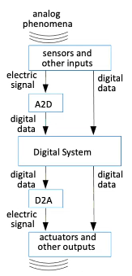

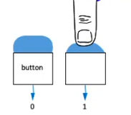Some inputs inherently binary

- Button: not pressed ( 0 ) , pressed ( 1 )

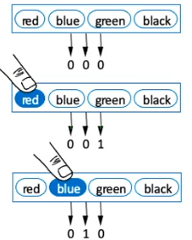Some inputs inherently digital

- Just need encoding in binary

- e.g., multi-button input: encode red=001, blue=010, …

Some inputs analog

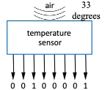 - Need a2d conversion

- As done in earlier, sample and encode with bits

How to Encode Text: ASCII, Unicode?

ASCII: 7 (or 8) bit encoding of each letter, number, or symbol

Unicode: Increasingly popular 16 bit encoding. Encodes characters from various world languages.

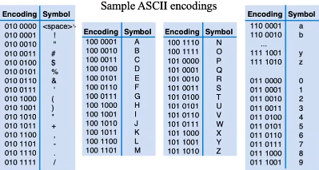

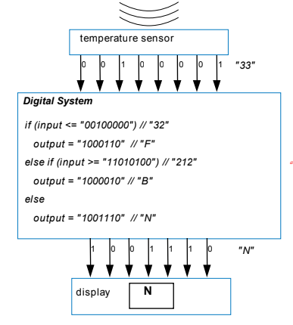

110 = 6

2

10

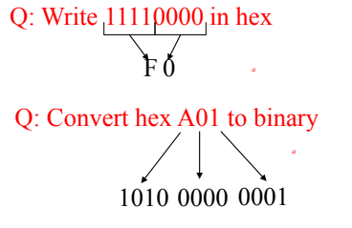

Decimal to Hex 🡪 convert to binary first, then binary to hex

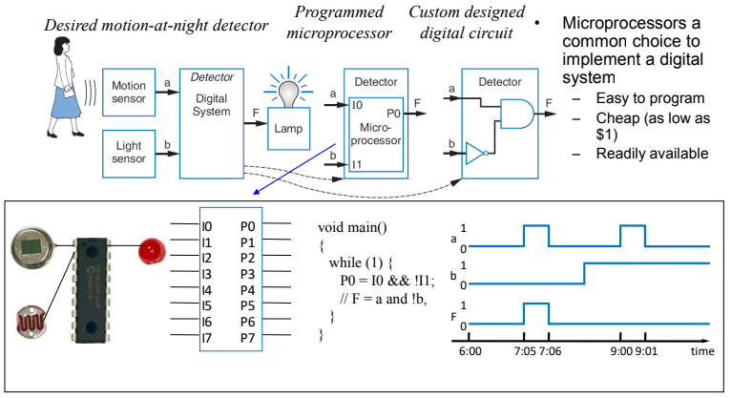

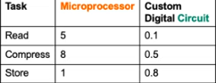With microprocessors so easy, cheap, and available, why design a digital circuit?

* Microprocessor may be too slow
* Or too big, power hungry, or costly

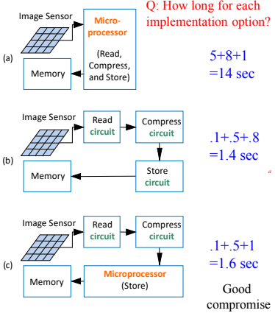

Digital systems surround us

* Inside computers
* Inside many other electronical devices (embedded systems)

Digital systems use 0s and 1s

* Encoding analog signals to digital can provide many benefits
  + e.g., audio -- higher quality storage/transmission, compression, etc.
* Encoding integers as 0s and 1s: Binary numbers

Microprocessors (themselves digital) can implement many digital systems easily and inexpensively

* But often not good enough -- need custom digital circuits